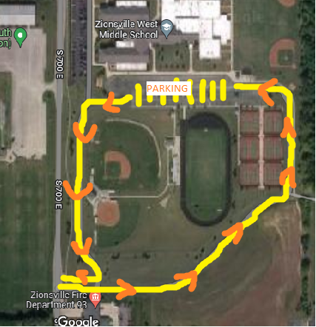

Please enter and exit by the Zionsville Fire Department.

